**Lab assessment for OVS BG Lab 6**

1. Can correctly show created bridges via openvswitch command
2. Can show the correct bound between br0 and enp0s3

Show the correct ipaddress assigned to br0

The ip is 10.0.2.33 as shown

Can show correct routing table for br0 and enp0s3 and ping 8.8.8.8

Lab 7 – Minet BG Lab

Assessment

Can correctly create topology with single switch and four hosts

Can correctly create a topology with 5 switches and one host for every switch

Show correct nodes, iperf net for each topology

Topology 1:

Topology 2:

Create a tree topology of depth 2 and fanout 8 and have h1 ping h64

Pox BG Lab – 8

Task 1:

Connect to a mininet topology

Start the forwarding.l2_pairs component:

Start the forwarding.l3_learning component

Task 2:

While connected to the controller, the mininet topology can: open the xterm terminal and ping command between two different hosts in two different xterm terminals

Open xterm and ping two different hosts

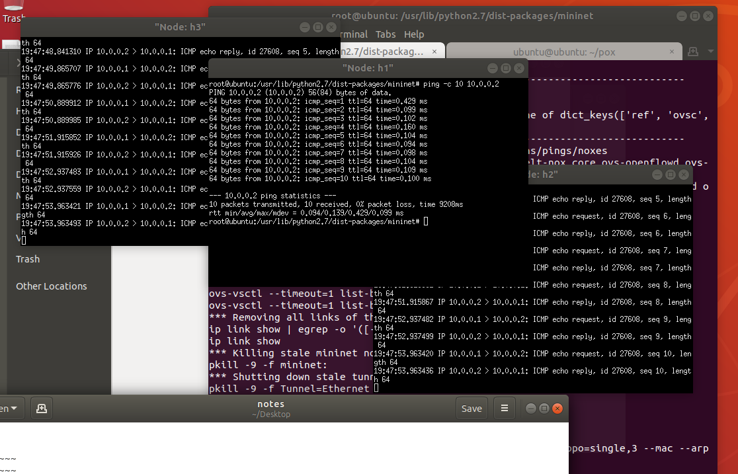

Lab 9 ContainerNet:

Sudo mn –test pingall

Python3 container_example.py

**The Lab!**

POX Location: /home/ubuntu/pox

OpenVSwitch Locations:

/usr/share/openvswitch/scripts

/var/run/openvswitch

ovs-ctl start

Task 1.0

Check if python is installed: python –version and python3 –version and mn –version and sudo mn –test pingall

Pox

Check ovs-vsctl

**Task 2.0**

Install

Running the example pox controller

Create the containernet:

Some pings, blocking TCP packets:

**Task 2.2 verify functionality**

